**Step 1: Understand Your Database**

* **Preview your data** (first 5 rows from each table):

SELECT * FROM City LIMIT 5;

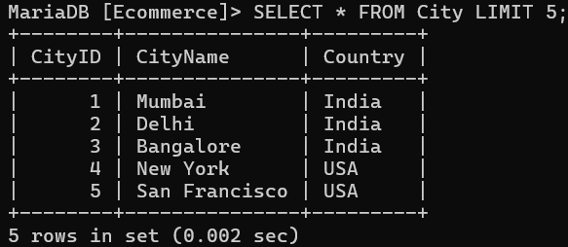

SELECT * FROM Customer LIMIT 5;

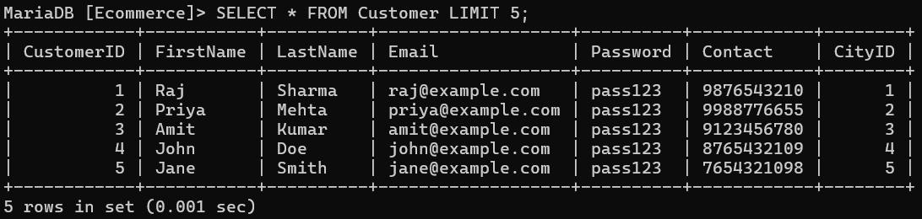

SELECT * FROM Category LIMIT 5;

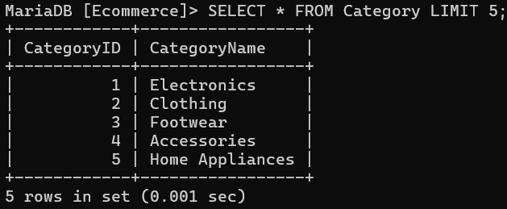

SELECT * FROM Product LIMIT 5;

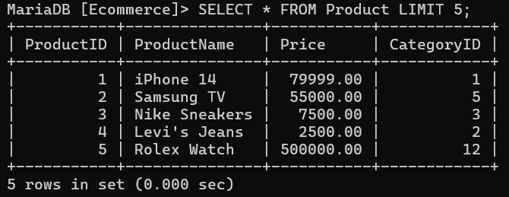

SELECT * FROM Orders LIMIT 5;

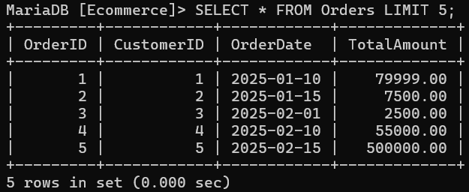

SELECT * FROM OrderedProduct LIMIT 5;

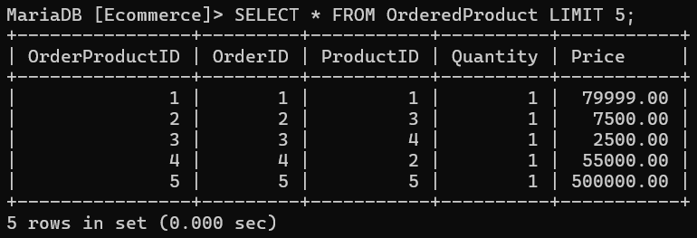

SELECT * FROM Review LIMIT 5;

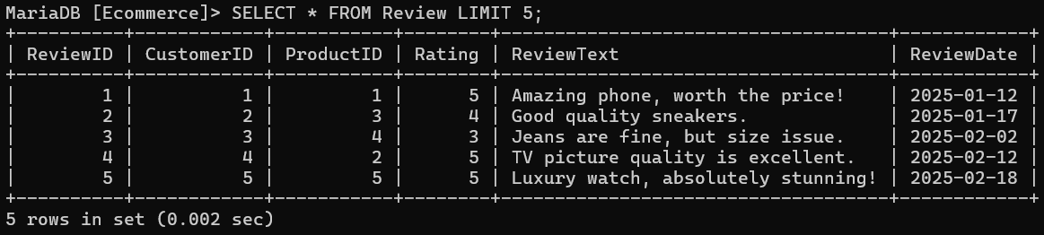

**Step 2: Basic SELECT Queries**

* **List all customers with their city:**

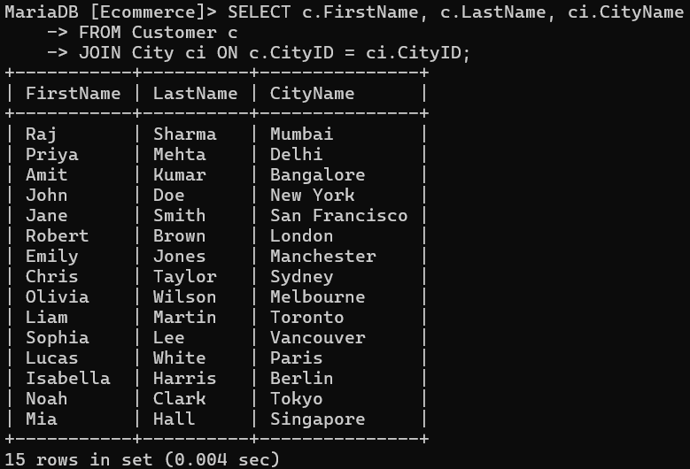

* **List all products and their categories:**

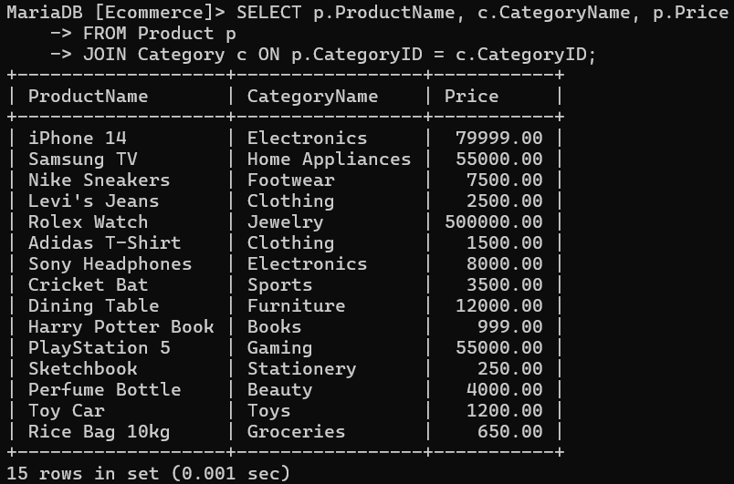

**Step 3: Filtering Data (WHERE Clause)**

* **Customers in a specific city:**

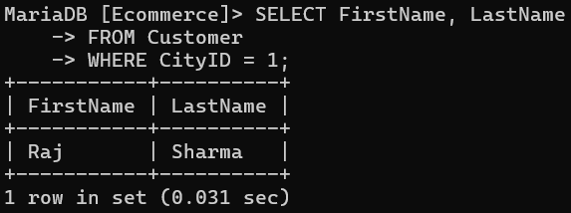

* **Products above a certain price:**

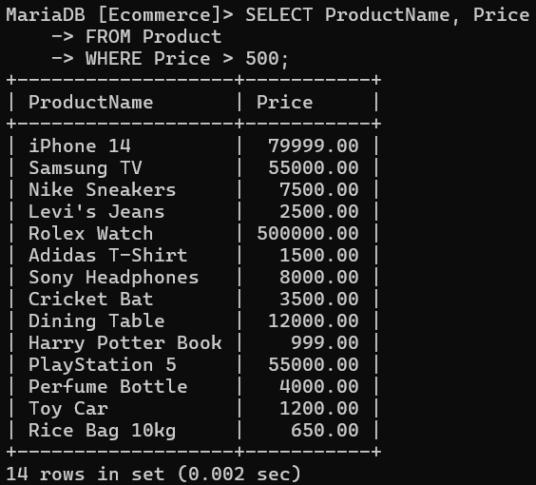

**Step 4: Sorting Data (ORDER BY)**

* **List products from highest to lowest price:**

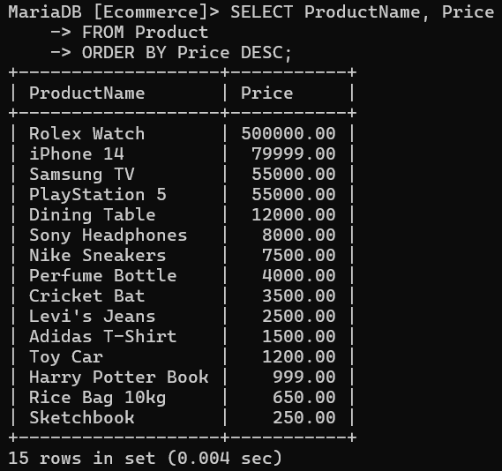

* **Orders by most recent date:**

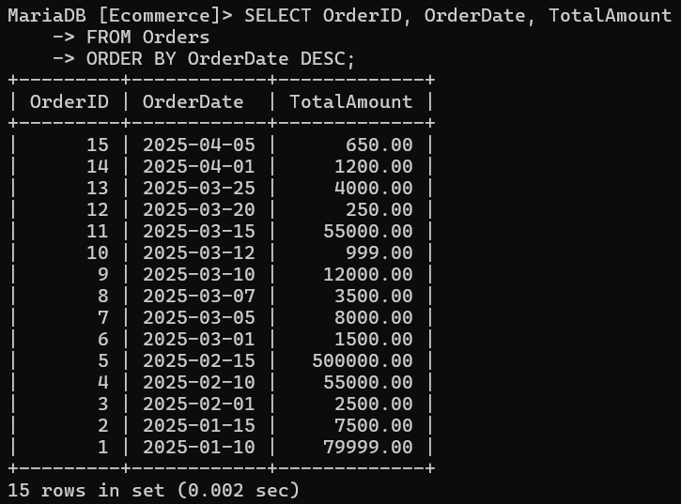

**Step 5: Aggregation (GROUP BY & Aggregate Functions)**

* **Total sales per product:**

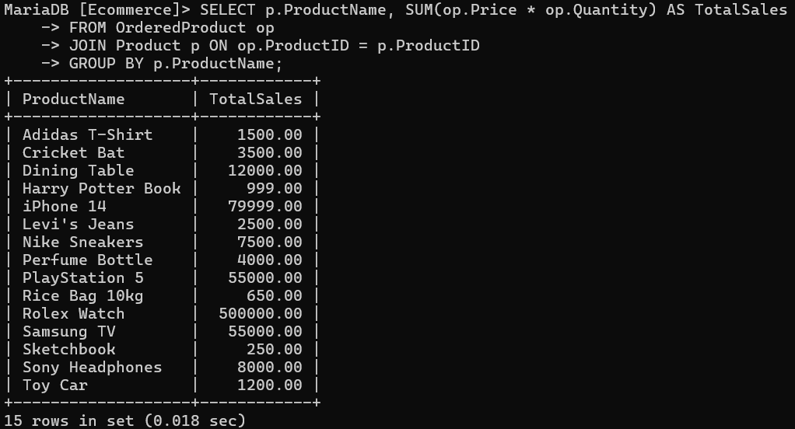

* **Average rating per product:**

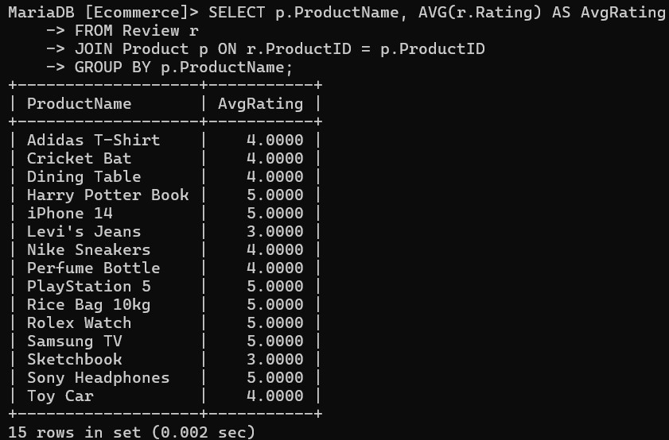

* **Number of orders per customer:**

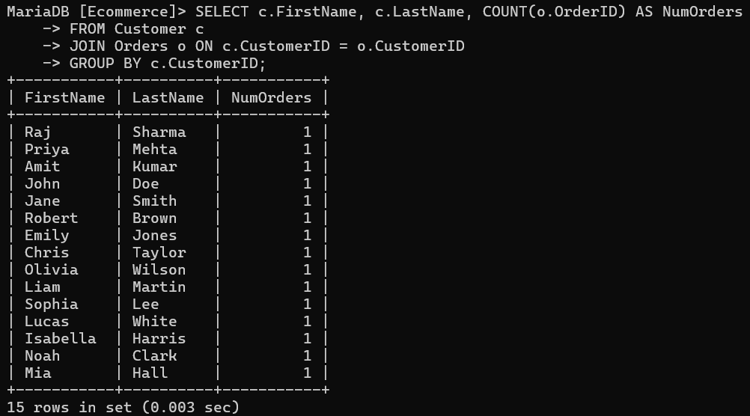

**Step 6: Joins**

* **List orders with product details and customer names:**

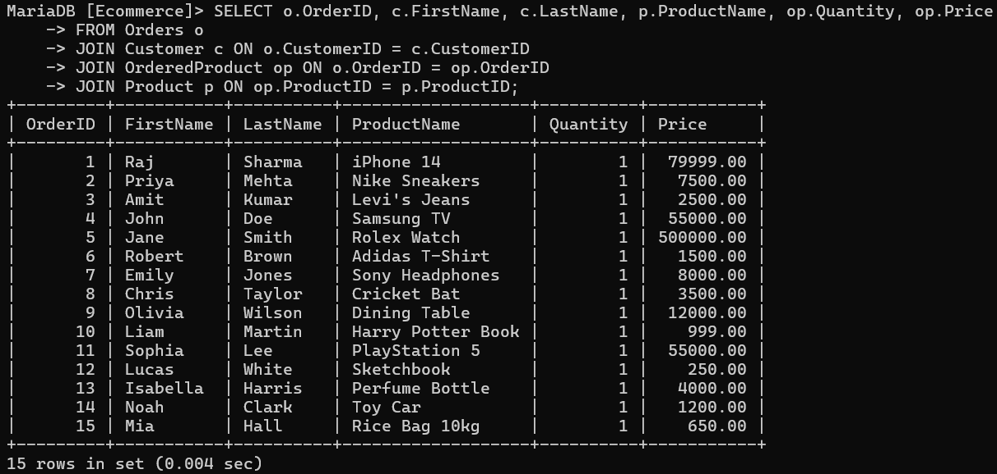

* **Left join to see customers with or without orders:**

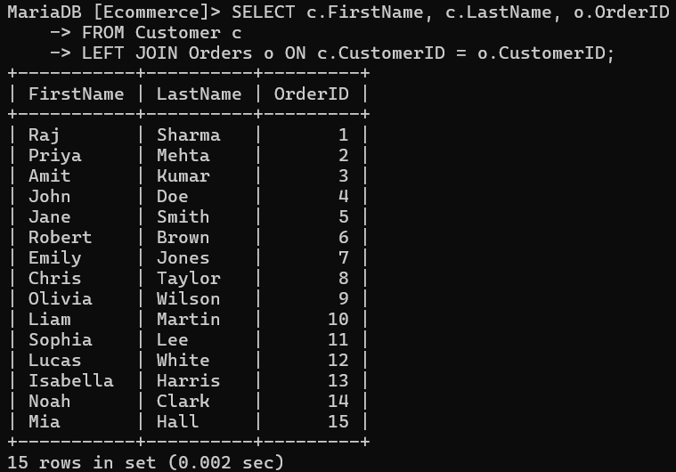

**Step 7: Sub-queries**

* **Find customers who spent more than average:**

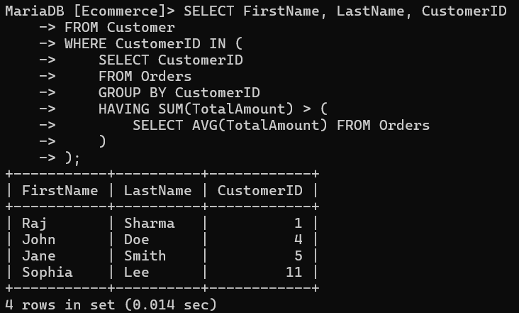

* **Products never ordered:**

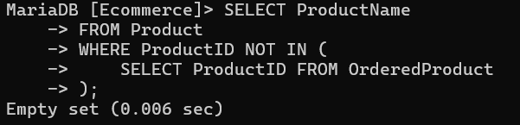

**Step 8: Views**

* **Create a view for easier analysis:**

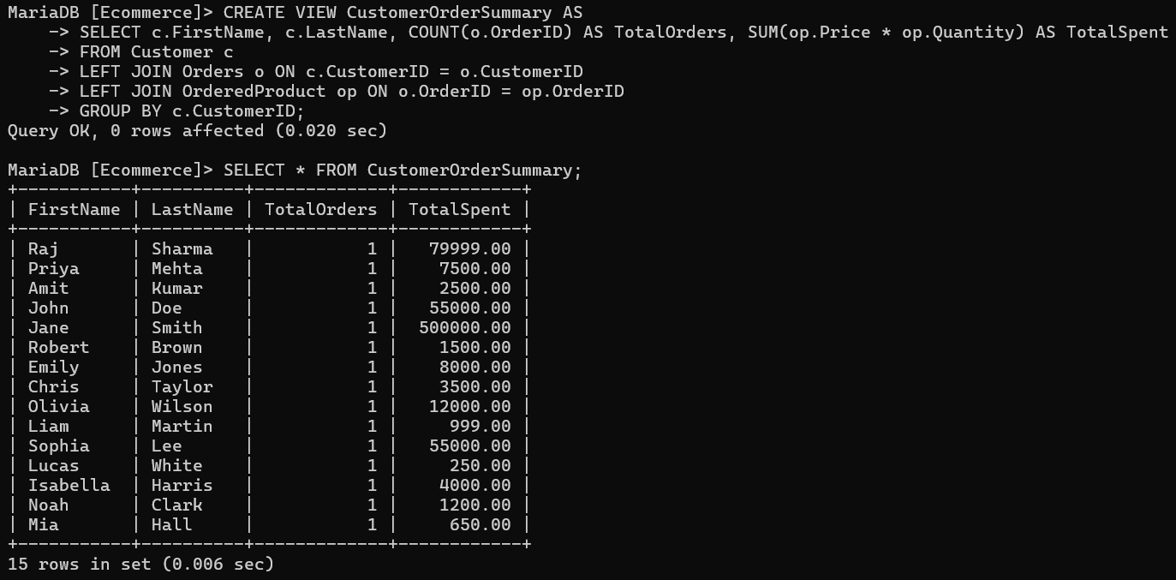

**Step 9: Indexing for Optimization**

* **Create indexes on frequently joined columns:**

